ShoppyGlobe Backend API

Build APIs with Node.js, Express.js and MongoDB

Submitted By:
Name: Nithil

Technology Used:
• Node.js
• Express.js
• MongoDB
• Mongoose
• JWT Authentication
• Thunder Client

MongoDB Products Collection
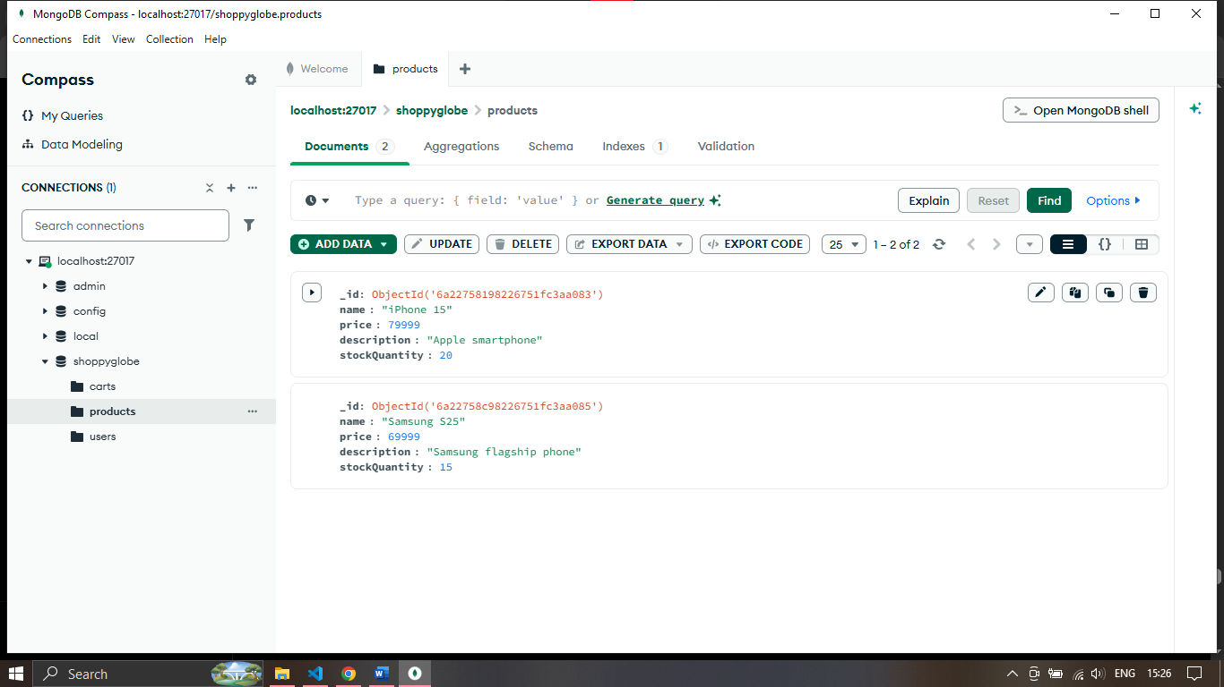

MongoDB Cart Collection
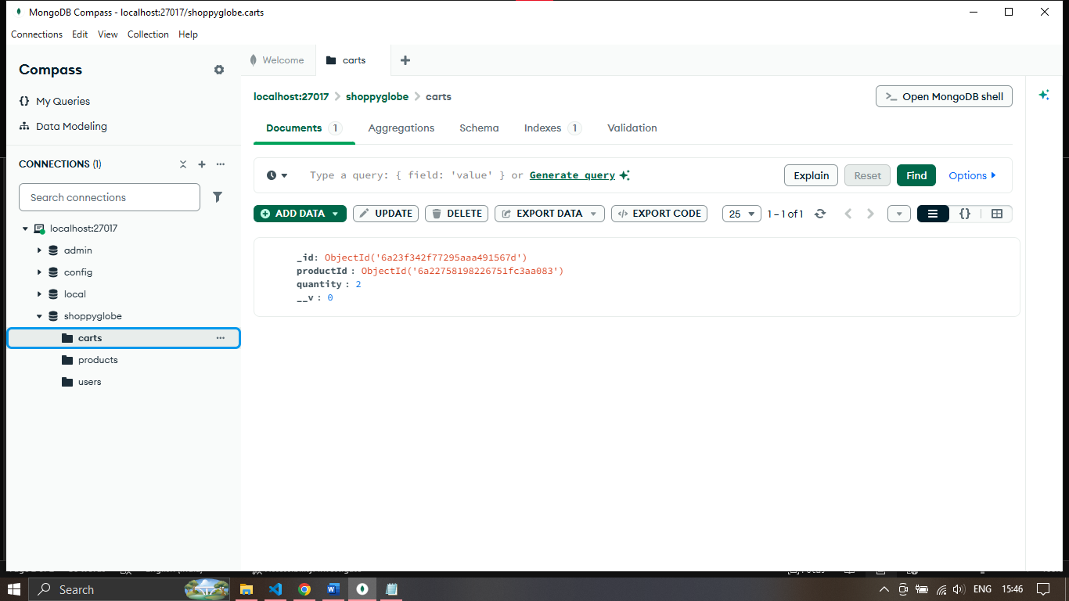

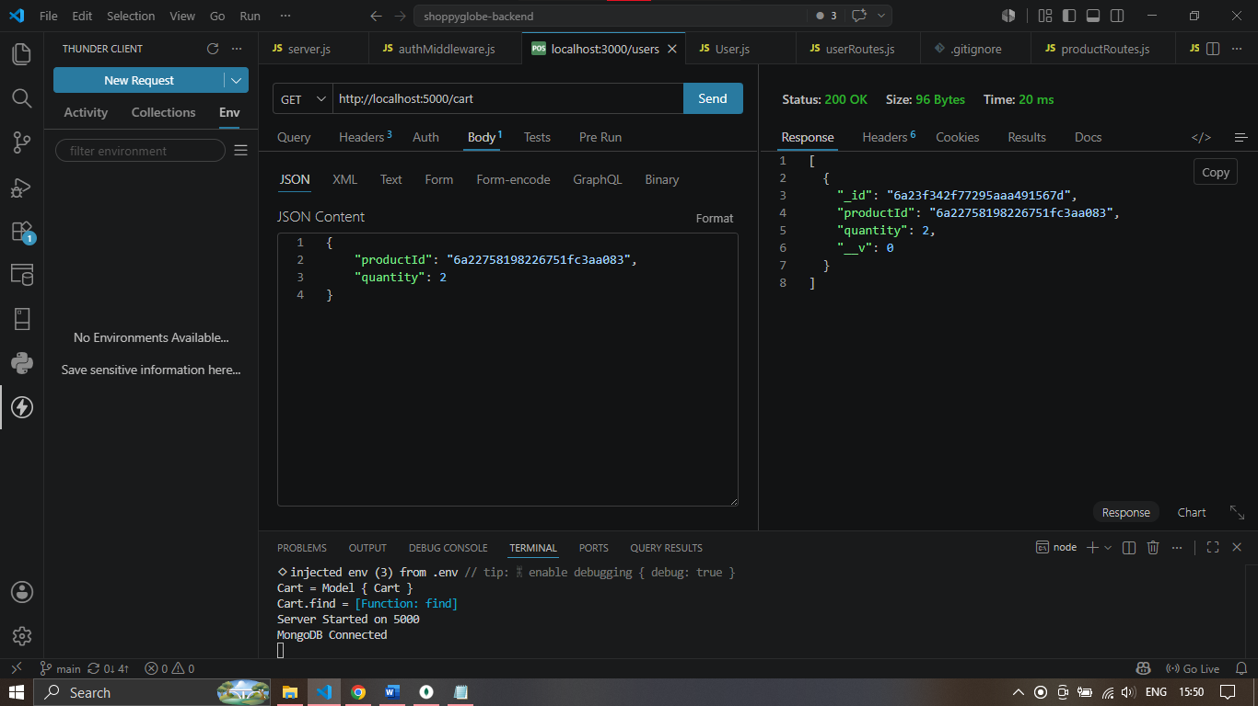

PUT /cart Screenshot

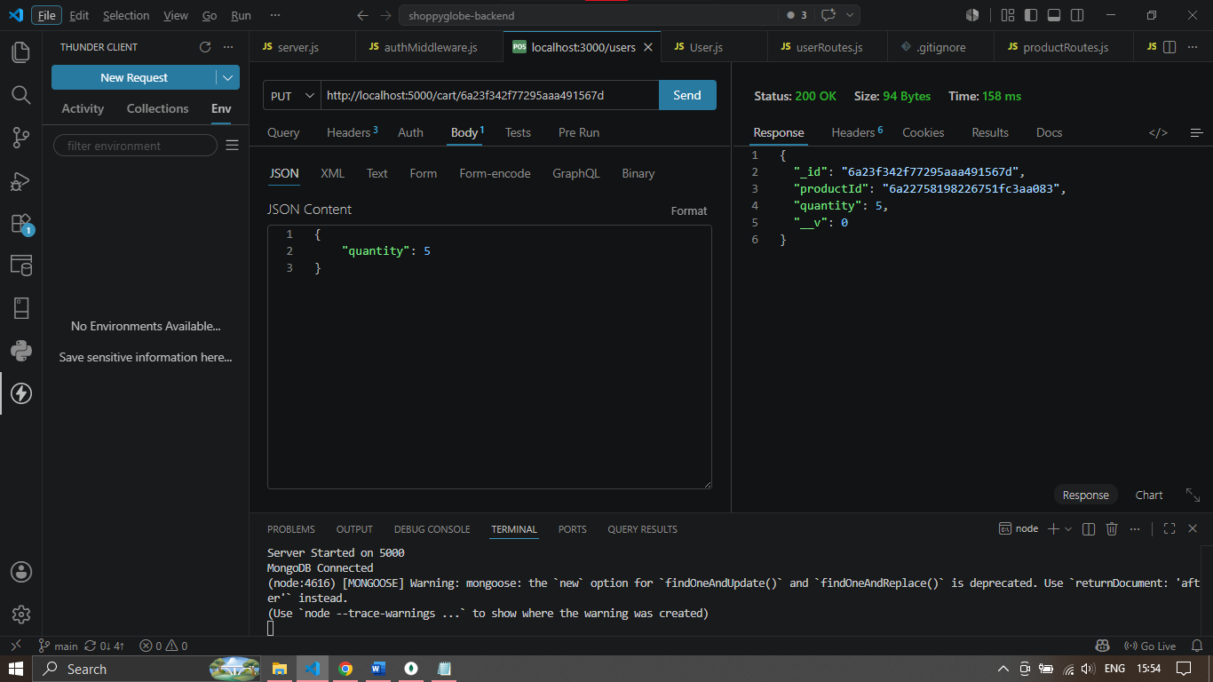

DELETE /cart
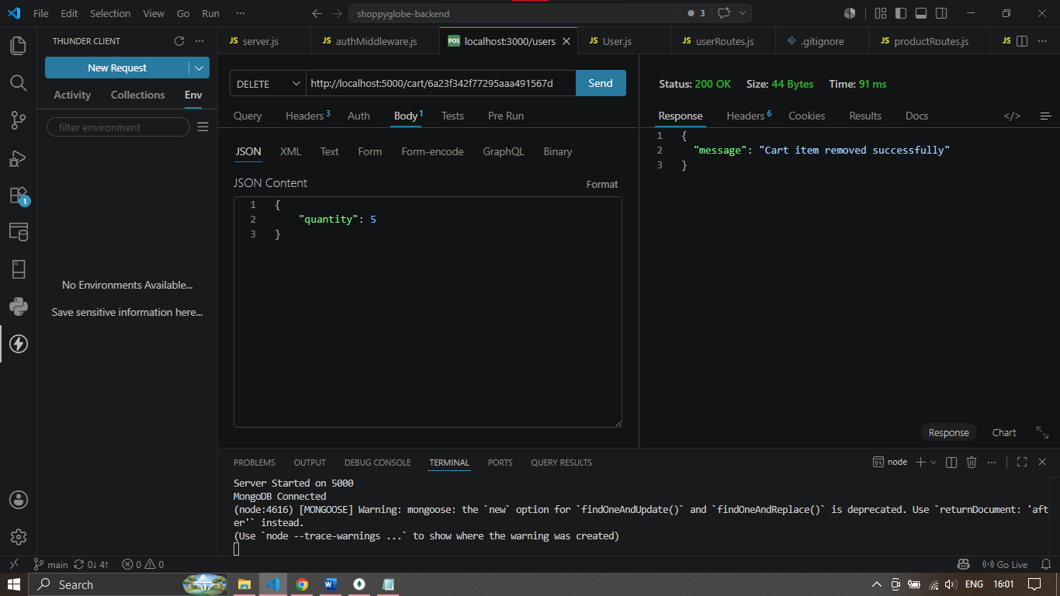

Protected Route Without Token
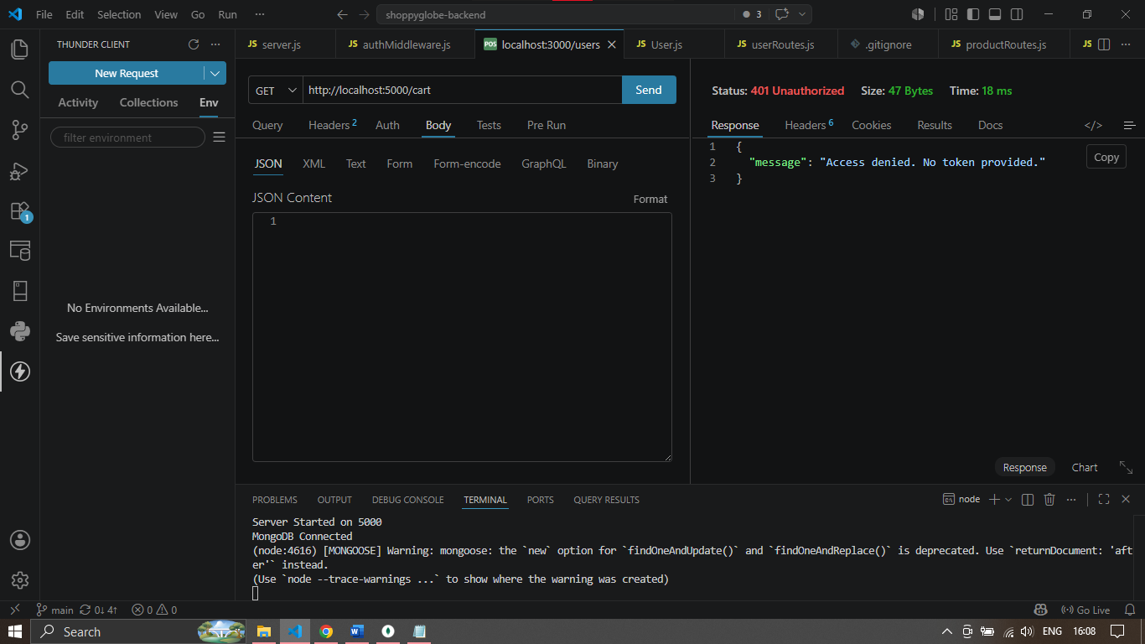

Protected Route With Token
